Edu Fit

Brandon Simmons, Christine DiFonzo, Austin Farr, Carrie Dougher, Ben Alden, Amro Al-suwaida, Muhammad Harris

1) Introduction

* 1. Project overview

A recent study led by the U.S. Department of Education, in coordination with representatives from each state’s board of education and a team of world-renowned health, fitness and nutrition professionals, has revealed that today’s teen athletes and their parents/guardians are greatly lacking in sufficient knowledge to ensure that the young athlete has the proper nutrition and fitness routine to support the increasingly rigorous training required by high school athletic programs. As a result, these young athletes are not optimizing their potential on the sports fields through proper off-season training as well as developing healthy nutritional habits. Some athletes even experience health issues and injuries!

Congress acknowledged the importance of youth athletic programs for a vast multitude of reasons and, as a result of this study, made the decision to allocate a generous budget to the DOE to further explore a solution to the issue. They have a team of individuals from the original study in charge of the effort. This team of experts (aka Subject Matter Experts or SMEs) has decided that engaging today’s teens in some type of subscription-based online gaming system would be the ideal solution to the problem. They are currently soliciting proposals from reputable web development companies throughout the country for potential solutions. This team fully admits that while they are experts in their respective fields that they are lacking when it comes to the latest technology, and they have stressed how vital it is that the solution be easy to use.

The general purpose of the website would be to create a fun, interactive learning environment for teens to become more aware of what they should be doing to maximize their performance in a given sport.

b) Project Deliverables

1. Requirements

2. Use Cases & Sequence Diagrams

3. HLA, Class Diagram, & Interface Spec

4. Repo Link

5. Software Project Management Plan

6. Presentation

7. Code Review Criteria

8. Code Review

9. Application of Code Review

c) Evolution of the SPMP

This document shall be updated as the project progresses and changes are made. The following sections should be updated as the project advances.

i. References

ii. Definitions, Acronyms, and Abbreviations

iii. Organizational Structure

iv. Methods, Tools, and Techniques

v. Project Deliverables

d) References

Slides

e)Definitions, Acronyms, and Abbreviations

HLA- High Level Architecture

SPMP- Software Project Management Plan

2) Project Organization

a)Process Model

The process used for this project is Evolutionary. The Evolutionary Process Model is an iterative cycle that allows us to create a version that allows us to start basic, and make it more and more complete as we proceed in the project. We understand well what is required of the customer, so we can easily implement the evolutionary model. Our prototyping is basic so that we can more easily see what we have done, and what we need to do based on the requirements.

b) Organizational Structure

Team Members:

i) Brandon Simons Documentation

ii) Christine DiFonzo Interface Design and Implementation

iii) Austin Farr Database Management and Scripting

iv) Carrie Dougher Interface Design and Implementation

v) Ben Alden Database Management and Testing

vi) Amro Al-suwaida Interface Design and Implementation

vii) Muhammad Harris Documentation

c) Organizational Boundaries and Interfaces

Team members will be responsible to coordinate within themselves, and push each other and themselves to complete team deliverables and coordinate.

d) Project Responsibilities

Responsibilities that each team member is mainly responsible for is listed in the Organizational Structure portion of this segment (2b), but ultimately each member has a responsibility to make sure that each component is complete for submission.

3) Managerial Process

a)Management Objectives and Priorities

Ultimately, the project is to create a website that caters to student athletes that allows them to track their fitness goals, let them communicate with their coaches, and facilitate the students with Trainers. There is an emphasis on a fun, interactive gaming environment for high school aged student athletes across the country.

b) Assumptions, Dependencies, and Constraint

Project Assumptions:

i. Appropriate Resources Available

ii. Access to equipment and software

iii. A system will check and delete trainers that get no service

iv. A system will change coaches if a coach is replaced

Project Dependencies:

i. All schools want to use the Edu Fit service

ii. Trainers want to use the Edu Fit service

Project Constraints

i. Time

ii. Experience

iii. Budget

iv. Available Services

c) Risk Management

i. Complexity

ii. Size of Project

d) Monitor and Controlling Mechanisms

i. Changing of the sponsor of the month.

e) Staffing Plan

i. Front End Design

ii. Style Designer

iii. Back End Designer

iv. Documentation

4) Technical Process

a) Methods, Tools and Techniques

This project will be used with tools such as Adobe Muse, MySQL Workshop, Filezilla, and GitHub. PHP scripts are to be used to communicate the database with the user's experience. Adobe Muse will be used to create the templates for the website. Filezilla will be used to push the user made PHP scripts onto the server.

b) Software Documentation

i. The software documentation such as Requirements, Use Case & Sequence Diagrams, HLA Diagram, Class Diagram, Interface Specification, Repository, SMPM (This Document), Presentation, Code Review Criteria, Code Review, and Deployment Plan. If a change is made High Level, then each document must show this changed applied to it.

c) Project Support Functions

i. Whenever there are either enough errors occur that a new version is needed, or a catastrophic error is found, the team will update the program for the customer.

ii. Configuration Management Plans will be Generated whenever a new version of the software is created.

iii. A Validation Plan will be created to ensure that any updates will ensure that the specifications set by the user will be maintained.

5) Work Packages

Work Breakdown Structure:

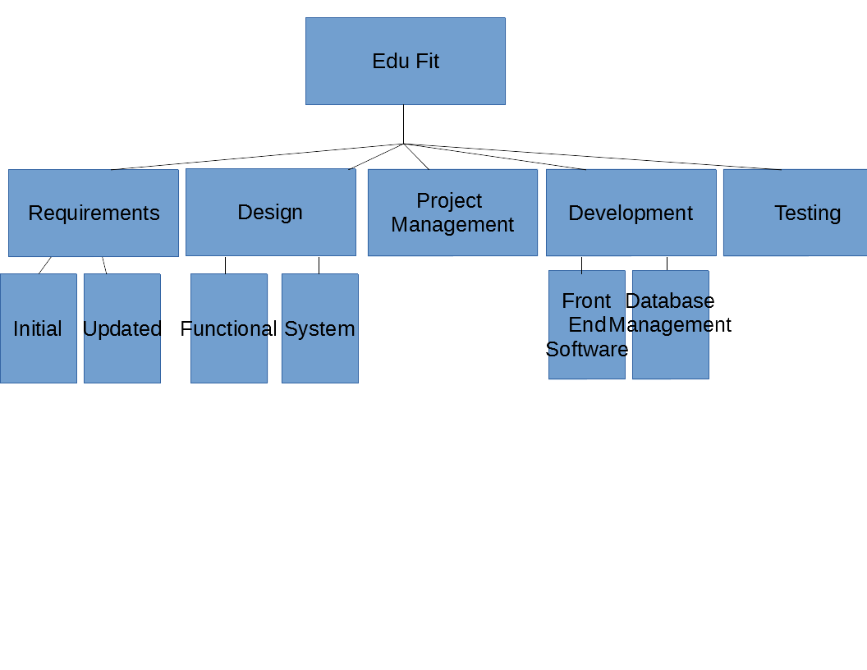

Dependencies:

Going left to right, with the exception of Project Management, each is dependent on the next. So Design is dependent on the Requirements, Development is dependent on the Design, and Testing is Dependent on Development. This goes along with the